Name: Keletso Joy Ditlhotlhole
Student ID: 202002023
Programme Code: BSc Computer Science
CSI223 LAB6

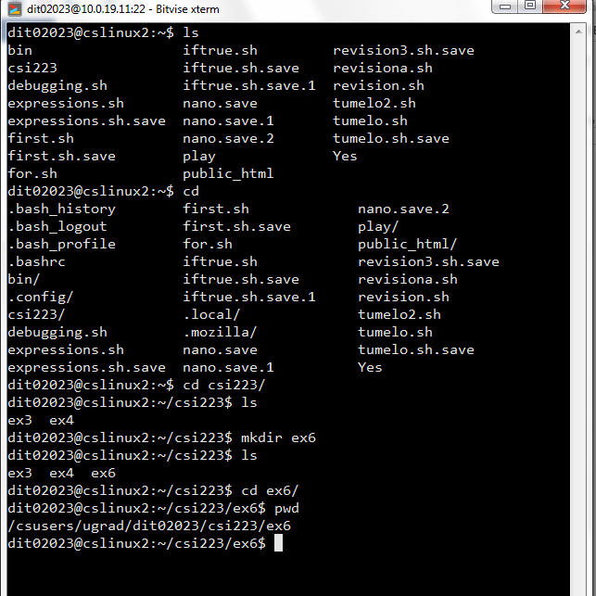

Exercise 1

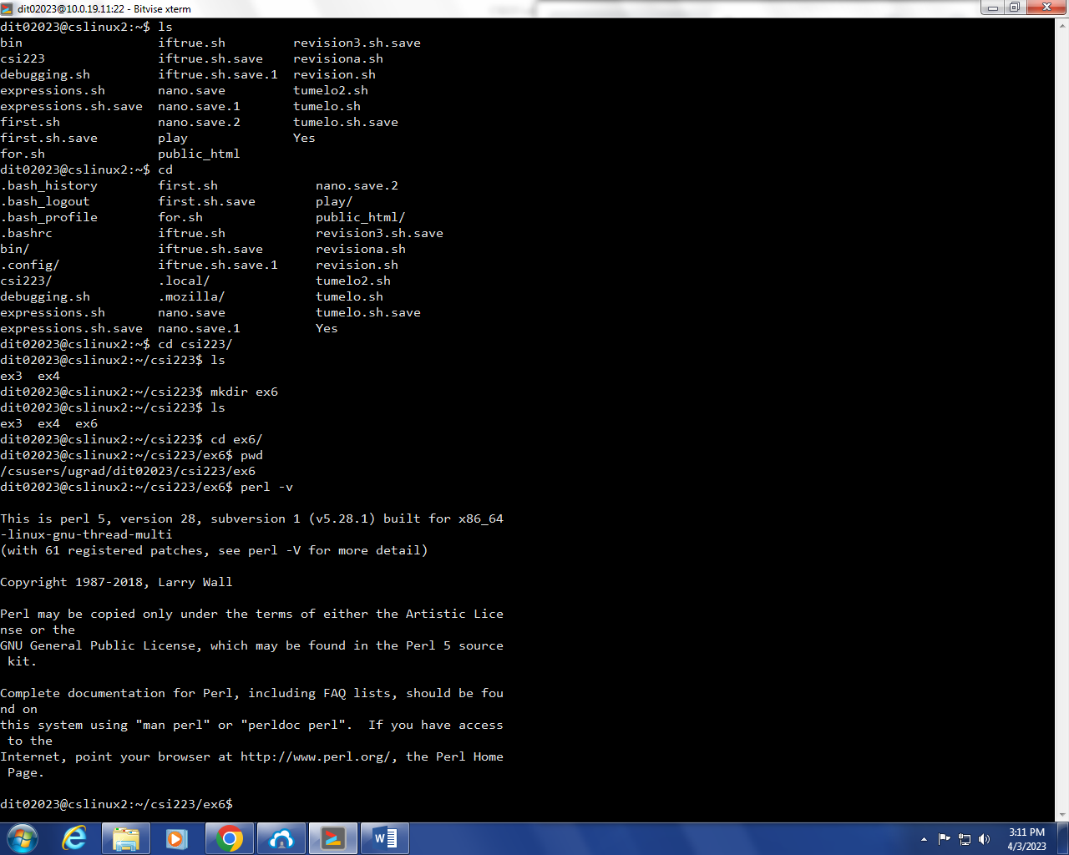
I am using Perl 5 version 28, subversion 1

Exercise 2: Perl Program: Hello World
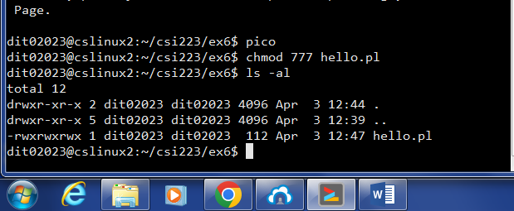

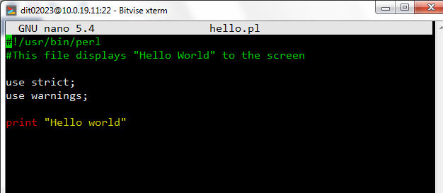
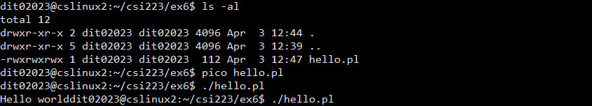

Exercise 3: Arithmetic
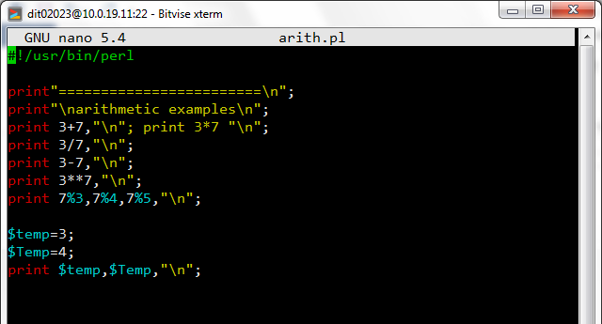

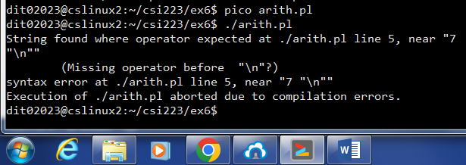
The code had errors.
The print in line number 5 was not recognized as it was in the same line as another print statement.

AFTER CORRECTING THE CODE
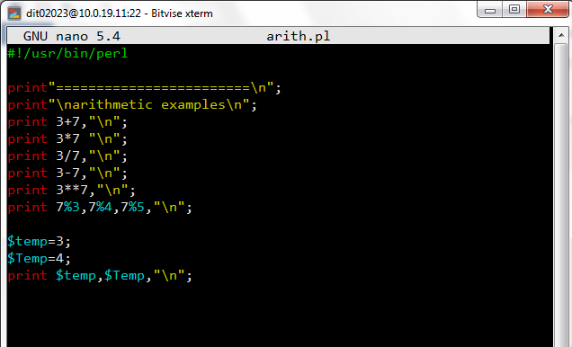
Output:
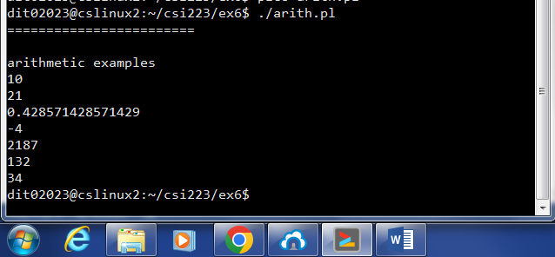

The “\n” in line two skips a line before outputting “arithmetic examples”.

Exercise 5: Variables
i.
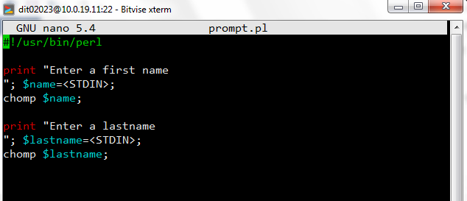

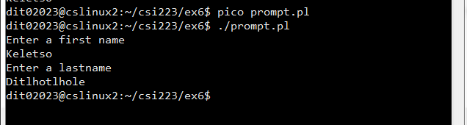

ii.
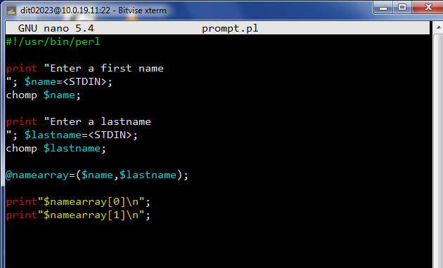
Output:
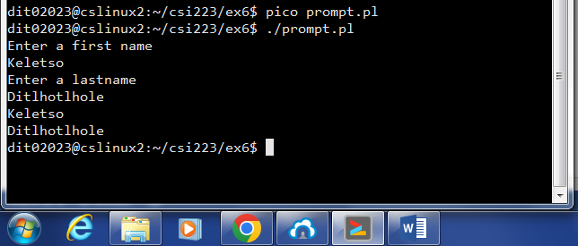

iii.
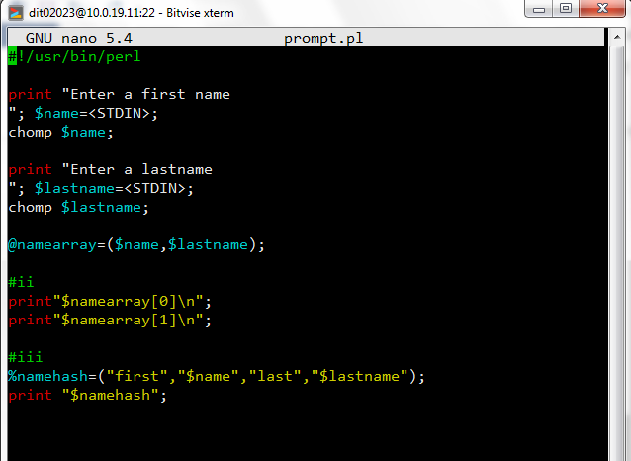
Output:
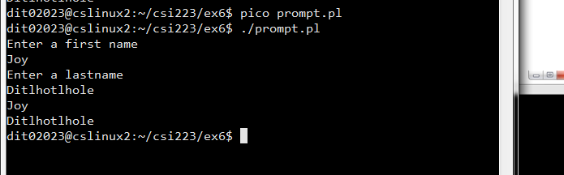

You cannot print hashes the same way you can resolute scalar variables in perl.

iv.
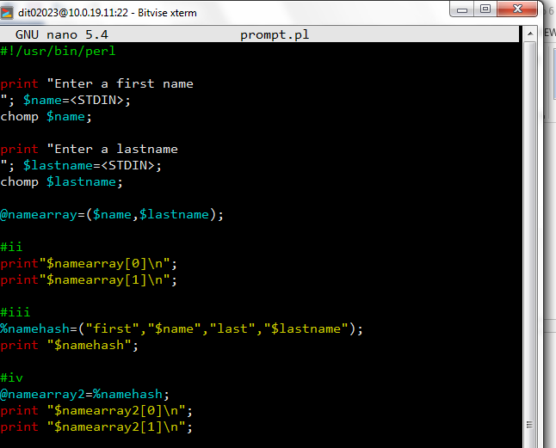
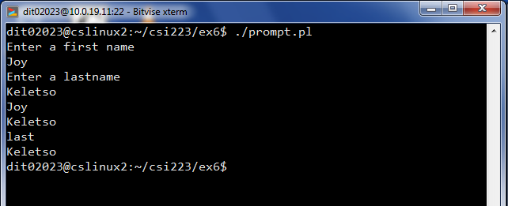

Instead of printing,
Joy
Keletso
It prints the key and value of the last element.

Exercise 5: Arrays
i.
Without interpolation
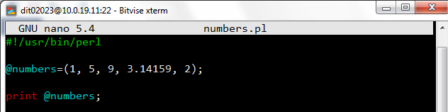
Output:
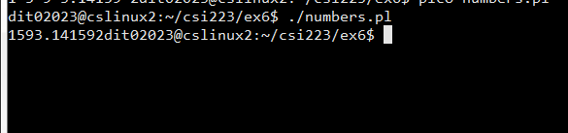
With interpolation
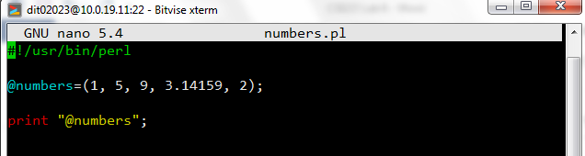
Output:
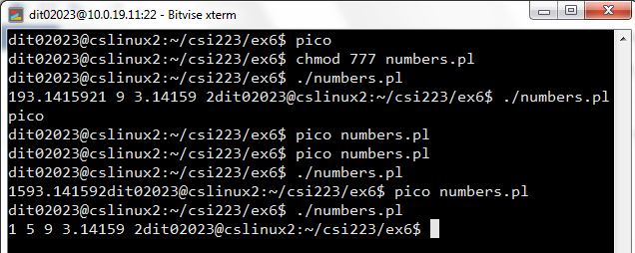

- With interpolation creates spaces between numbers while without interpolation does not space the numbers.

ii.
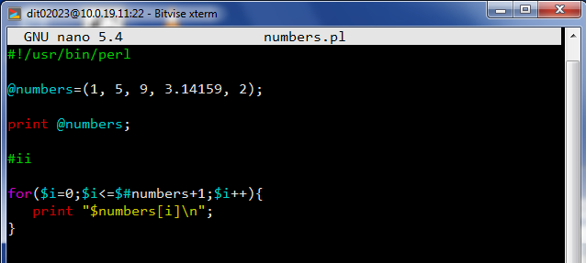

iii. ‘\n’ prints a new line for characters while “\n” prints a new line for strings.

